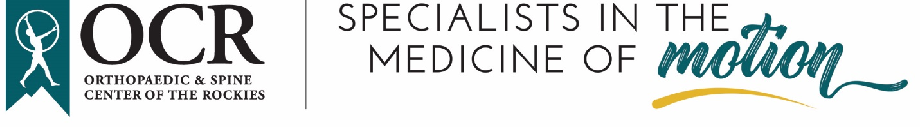
Orthopaedic & Spine Center of the Rockies Primary Care Sports Medicine Physician
The Orthopaedic & Spine Center of the Rockies (OCR) is seeking a fellowship-trained Primary Care Sports Medicine Physician to join our esteemed team in early 2025. Located in northern Colorado, we are the largest independent orthopedic practice serving patients from Colorado, Wyoming, Nebraska, and beyond.
OCR (Orthohealth.com) is a private, physician-owned medical group with 49 physicians and close to 100 total providers. We offer a full spectrum of orthopedic subspecialties, including: Adult and Pediatric Spine Surgery, Athletic & Reconstructive Surgery of the Foot & Ankle, Hand & Upper Extremity Surgery, Hip Arthroscopy, Joint Replacement Surgery, Non-Operative Sports Medicine, Pediatric Orthopedic Surgery, Physical Medicine & Rehabilitation, Podiatric Medicine & Surgery/Diabetic Foot & Wound Care, Sports Concussion/Neuropsychology, and Trauma & Fracture Surgery
OCR was founded in 1969 in Fort Collins, CO, and has six medical campuses in Fort Collins, Loveland, Greeley, Longmont, Lafayette, and Westminster. OCR serves patients from the regions of Northern Colorado, Wyoming, and Nebraska.
OCR is a member of a large collaboration of 100 independently owned orthopedic specialty groups across 37 states (Theorthoforum.com/about-us). As a result of our exceptional quality of care, OCR is consistently ranked among the top practices in the United States.
OCR is the medical team for Colorado State University (CSU) Athletics, the Colorado Eagles Hockey Team (AHL), and numerous area High School sports programs, club sports, and regional rodeo programs.
Requirements:
To be considered for this position, the candidate should possess the following qualifications:
- MD/DO degree from an accredited medical school
- Licensure or license-eligible in the state of Colorado
- Fellowship training in Primary Care Sports Medicine
- Board Certification or Board Eligibility in Primary Care Sports Medicine
OCR Facts:
A physician-owned vertically integrated private medical group for over 55 years
- 6 medical campuses + satellite clinic for Division 1 athletes at Colorado State University
- 3 Ambulatory Surgery Center and 2 Recovery Center locations
- 3 MRI centers
- 5 Therapy clinics
- Outstanding benefits include health, life, dental, disability, relocation assistance, 401k plan, cash balance pension plan, & profit sharing
Our vibrant communities of Fort Collins, Loveland, and Greeley are nestled in the foothills of the Rocky Mountains, providing easy access to world-class outdoor activities, including skiing, mountain biking, and hiking. Northern Colorado's blend of professional growth opportunities and a lifestyle immersed in nature, strong community, and cultural experiences makes it an ideal place to call home.
To learn more about this opportunity, please contact:
Carli Taylor-Drake
Director of Marketing & Practice Development
Orthopaedic & Spine Center of the Rockies
2500 E. Prospect Rd
Fort Collins, CO 80525
970-419-7140
ctaylordrake@orthohealth.com

